Gravity for Ten-Year-Olds

Based on ideas from Alan Kay.

Day 1:
Teach children how to build a discrete model of constant acceleration, with an initial velocity of 1 downwards, and an increment of 2. Thus:
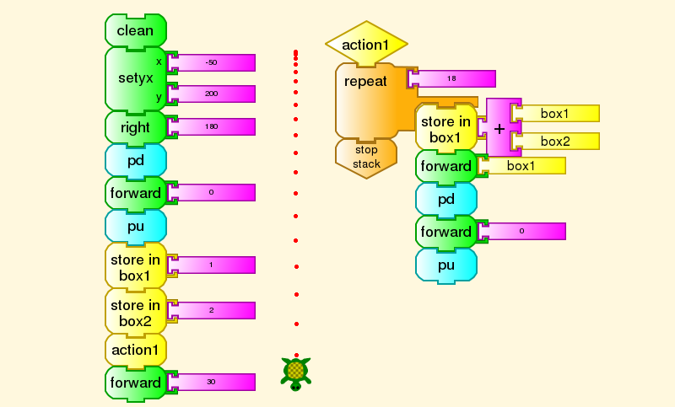
This assumes, of course, that we have taught the children enough Turtle Art to understand this construction. You can see that the dots going downward get further and further apart. Going through the program, we see that the intervals are
1 3 5 7 9 etc., the first 18 odd numbers
If we add initial segments of the odd numbers to get the position of each dot, we find
1 4 9 16 25 etc., the first 25 squares.
We can do some more work on these ideas. For example, here is a visual proof that the differences between successive squares are successive odd numbers. We can follow this up at an appropriate age with the corresponding algebra: . We can also, at that point, demonstrate that the formula for motion under constant acceleration is . In this formula, d is distance, a is acceleration, and t is time.

Day 2:
Get the children outside with their XOs, and have them get ready with the video camera function in record. At a signal, have the children record start recording a person with a ball on the roof of the school, who then drops the ball. Show the children how to overlay frames from their videos to get this effect:
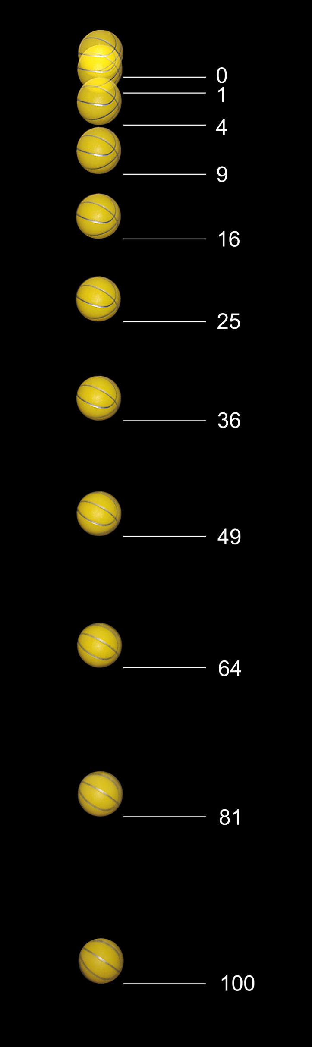
Can the children recognize the pattern? Certainly.

Day 3:
Let’s add a little something to our model—constant sideways motion. This is what we get.
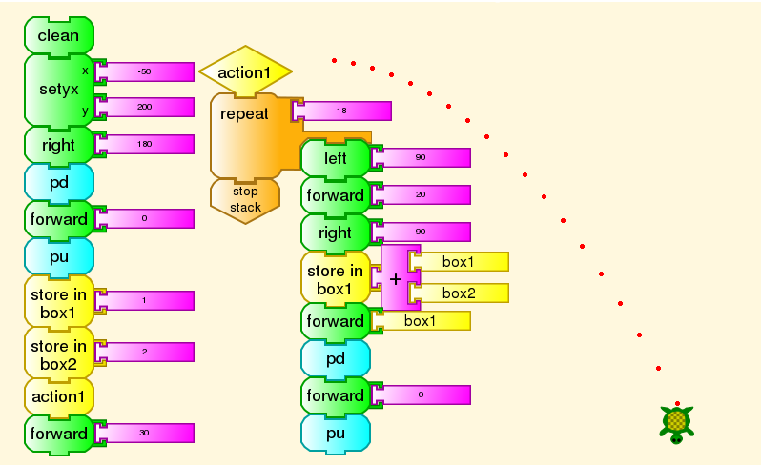
Some of you will recognize that these dots lie on a parabola, a well-known conic section discovered and analyzed by Greek mathematicians, most notably Appolonius of Perga, in the time of Euclid. Galileo gave a proof that constant horizontal motion and uniformly accelerated vertical motion necessarily produces a parabolic path. He also pointed out that a person dropping an object from the mast of a ship will see it fall straight down, while an observer on shore, or on another ship, sees its path as a parabola. This is part of Galilean Relativity, which reigned supreme in physics for nearly 400 years, until observations became precise enough to demand Einstein’s Special Relativity.
We can obviously do more math here. The sideways increment does not have to be 20, as in the Turtle Art program above. You will get a parabola for any increment except 0. It turns out that all of these parabolas have the same shape, although they are wider or narrower as we see them here. There is only one parabolic shape, but it can appear in any size.

Discussion
We have given the children sufficient tools and sufficient hints to do in three days what Galileo spent years on, with no computer, no camera, not even a clock. He discovered the principle of the pendulum in 1602, but it was more than 50 years later that Christian Huygens built the first pendulum clock.
Galileo, of course, went into gravity and related matters in much more detail, and discovered much more than the law of constant acceleration in time, parabolic motion, or even Galilean Relativity. Since he used no math more advanced than Euclidean geometry and very elementary algebra, we can show most of his work to grade-school students.
In fact, the Classical Greek mathematicians had all the tools needed to do this. Why didn’t they? We don’t really know. There seems to have been a notion that geometry was an almost entirely abstract study, so that nobody would have looked for geometric figures in nature, apart from astronomy. We do know that those Greek mathematicians had often seen the parabolic arc of water, wine, or oil pouring through the air. We have the remnants of their fountains and their jugs. For example,
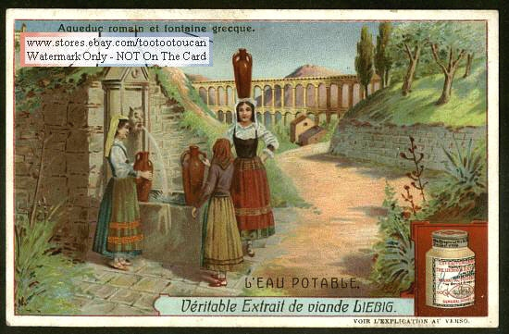or, in our time,

or
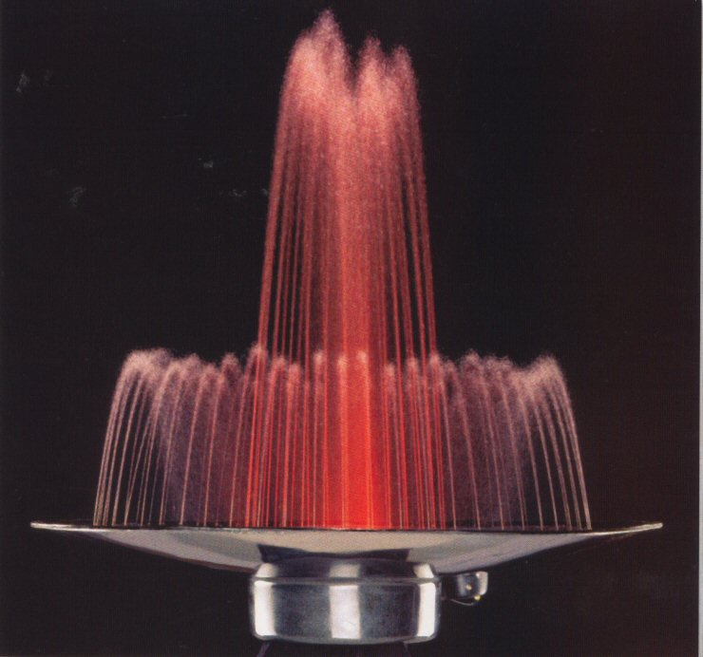
or
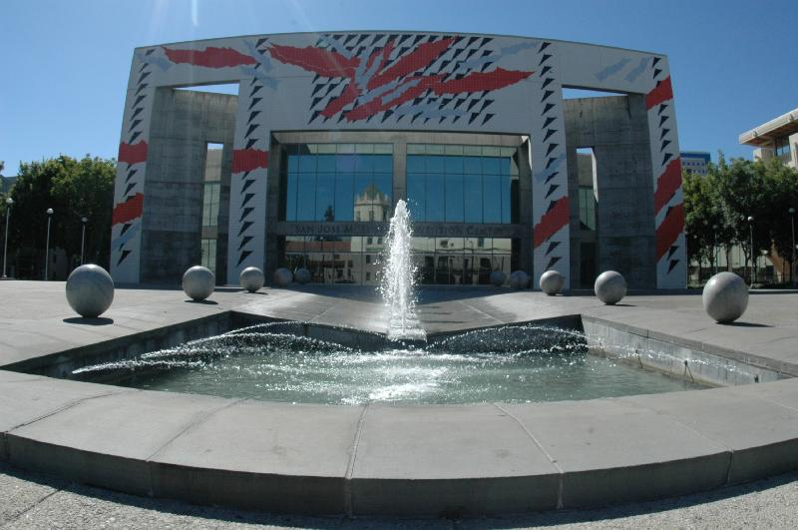
Leonardo da Vinci knew something about this. He drew the paths of cannonballs in his notebooks, and described the law of constant acceleration, more than a century before Galileo. Unfortunately, he was unable to publish any of his scientific work.
We have a lot to do in order to turn each topic in physics into a discovery such as Alan Kay worked out, and I have demonstrated here. Similarly for math and other sciences, and in fact for every other subject, using not just Turtle Art, but many other Sugar Activities. Even sports. The trajectory of a batted baseball, football, soccer ball, or cricket ball is approximately a parabola. Of course, they can curve in other ways with sufficient spin. But that is a topic for another day.

